Physics Enhancement Programme for Gifted Students (2016-2017)
Hong Kong University of Science and Technology (HKUST) and Hong Kong Baptist University (HKBU)

Phase 1 in HKUST (Sessions 1 to 19 has been conducted in HKBU during the summer of 2016.)
Session | Date | Time | Topic / Instructor | Instructor / Tutors | Venue
20 | Sat, 3 Sep 2016 | 09:30-12:30 | Lecture: Electromagnetism I | Dr. T. W. Chen | LTK, HKUST
21 |  | 14:00-17:00 | Tutorial | Harry Tam, Tony Shing, Apollo Wong, Tony Fung | 2610, 2611, 2612A, 2612B, HKUST
22 | Sat, 10 Sep 2016 | 09:30-12:30 | Lecture: Electromagnetism II | Dr. T. W. Chen | LTK, HKUST
23 |  | 14:00-17:00 | Tutorial | Harry Tam, Tony Shing, Apollo Wong, Tony Fung | 2610, 2611, 2612A, 2612B, HKUST
24 | Sat, 17 Sep 2016 | 09:30-12:30 | Lecture: Electromagnetism III | Dr. T. W. Chen | LTK, HKUST
25 |  | 14:00-17:00 | Tutorial | Harry Tam, Tony Shing, Apollo Wong, Tony Fung | 2610, 2611, 2612A, 2612B, HKUST
26 | Sat, 24 Sep 2016 | 09:30-12:30 | Lecture: Electromagnetism IV | Dr. T. W. Chen | 4619, HKUST
27 |  | 14:00-17:00 | Tutorial | Harry Tam, Tony Shing, Apollo Wong, Tony Fung | 2610, 2611, 2612A, 2612B, HKUST
28 | Sat, 8 Oct 2016 | 09:30-12:30 | Lecture: Electromagnetism V | Dr. T. W. Chen | LTK, HKUST
29 |  | 14:00-17:00 | Tutorial | Harry Tam, Tony Shing, Jacky Chau, Tony Fung | 2610, 2611, 2612A, 2612B, HKUST
30 | Sat, 15 Oct 2016 | 09:30-12:30 | Lecture: Electromagnetism VI | Dr. Y. F. Ng | LTK, HKUST
31 |  | 14:00-17:00 | Tutorial | Harry Tam, Tony Shing, Jacky Chau, Tony Fung | 2610, 2611, 2612A, 2612B, HKUST
32 | Sat, 22 Oct 2016 | 09:30-12:30 | Lecture: Optics I | Dr. T. P. Choy | LTK, HKUST
33 |  | 14:00-17:00 | Tutorial | Harry Tam, Tony Shing, Jacky Chau, Tony Fung | 2610, 2611, 2612A, 2612B, HKUST
34 | Sat, 29 Oct 2016 | 09:30-12:30 | Lecture: Optics II | Dr. T. P. Choy | LTK, HKUST
35 |  | 14:00-17:00 | Tutorial | Harry Tam, Tony Shing, Jacky Chau, Tony Fung | 2610, 2611, 2612A, 2612B, HKUST
36 | Sat, 5 Nov 2016 | 09:30-12:30 | Lecture: Optics III | Dr. T. P. Choy | LTK, HKUST
37 |  | 14:00-17:00 | Tutorial | Harry Tam, Tony Shing, Jacky Chau, Tony Fung | 2610, 2611, 2612A, 2612B, HKUST
38 | Sat, 12 Nov 2016 | 09:30-12:30 | Lecture: Special Relativity | Dr. Y. F. Ng | LTK, HKUST
39 |  | 14:00-17:00 | Tutorial | Harry Tam, Tony Shing, Wai Ting Tai, Tony Fung | 2610, 2611, 2612A, 2612B, HKUST
40 | Sat, 19 Nov 2016 | 09:30-12:30 | Lecture: Modern Physics / Quantum Mechanics | Dr. T. P. Choy | LTK, HKUST
41 |  | 14:00-17:00 | Tutorial | Harry Tam, Tony Shing, Wai Ting Tai, Tony Fung | 2610, 2611, 2612A, 2612B, HKUST
42 | Sat, 26 Nov 2016 | 09:30-12:30 | Lecture: Astrophysics and Astronomy | Dr. T. P. Choy | LTK, HKUST
43 |  | 14:00-17:00 | Selection Test II | Harry Tam, Tony Shing, Wai Ting Tai, Tony Fung | 2610, 2611, 2612A, 2612B, HKUST
44 | Sat, 3 Dec 2016 | 09:30-12:30 | Lecture: Experimental Physics | Dr. Y. F. Ng | TBA, HKUST
45 |  | 14:00-17:00 | Tutorial | Harry Tam, Tony Shing, Wai Ting Tai, Tony Fung | TBA, HKUST

The location of Lecture Theatre K (LTK) is circled on the map below. Room 4619 is accessed via Lifts 31-32.
The tutorials led by the 4 tutors are, in respective orders, Room 2610, Room 2611, Room 2612A, Room 2612B. The rooms are accessed via Lift 31 – 32.
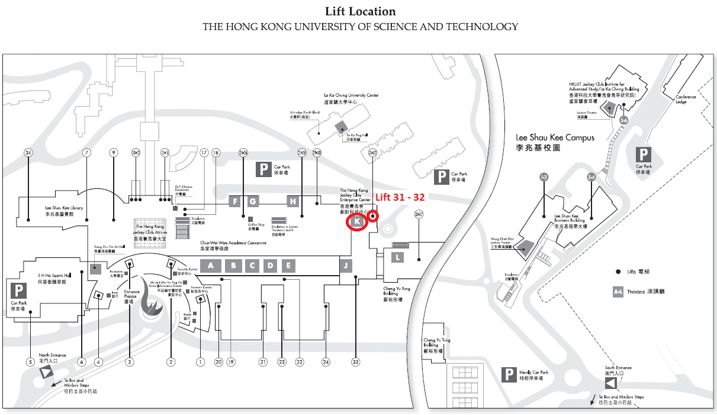

PEP Phase I training rules
- Phase I students who have 70% or above attendance rate will receive a certificate from the HKAGE. For attendance and leave policy, please check http://www.hkage.org.hk/files/students/important-information/Policies_and_Forms/20151001_Attendance%20and%20Leave%20Policy_E.pdf

- Phase I students who have been promoted to Phase II previously can choose to attend the lectures and the tutorials at their own discretion. They must notify HKUST or HKBU in advance with evidence (e.g HKAGE learning record) showing that they were in Phase II before. However, they still need to attend all the selection tests.

- Phase I students must attend all the selection tests. Zero mark will be given for those whose are absent from selection test(s).

- The assessment of phase I consists of
- Selection Test 1 ----------------- 50%
- Selection Test 2 ----------------- 50%

- Promotion to Phase 2: Top 30 students based on the total score of two selection tests.
Last Update: 7 September 2016

